# CREATING A VIRTUAL MACHINE USING A PUBLIC CLOUD SERVICE PROVIDER (AZURE)

**STEP – 1:**

Create a new virtual machine.

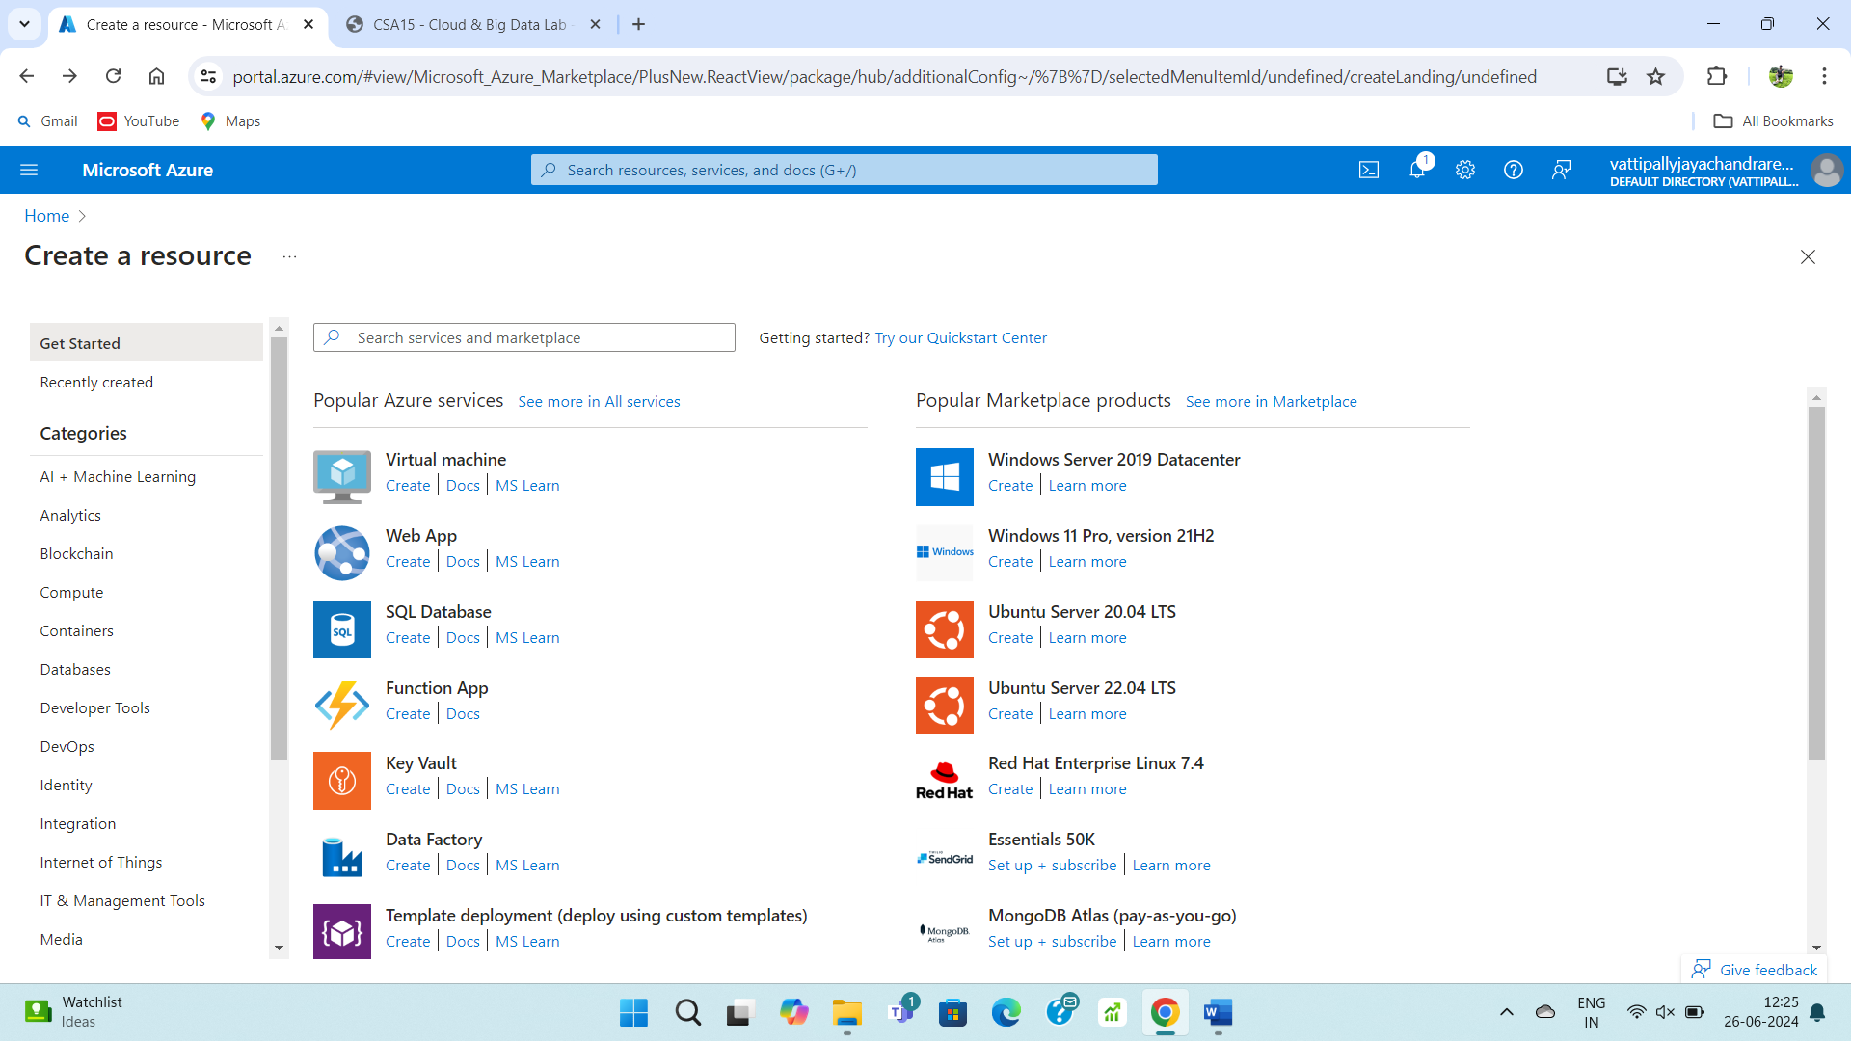

**STEP – 2:**

Fill upon the basics form.

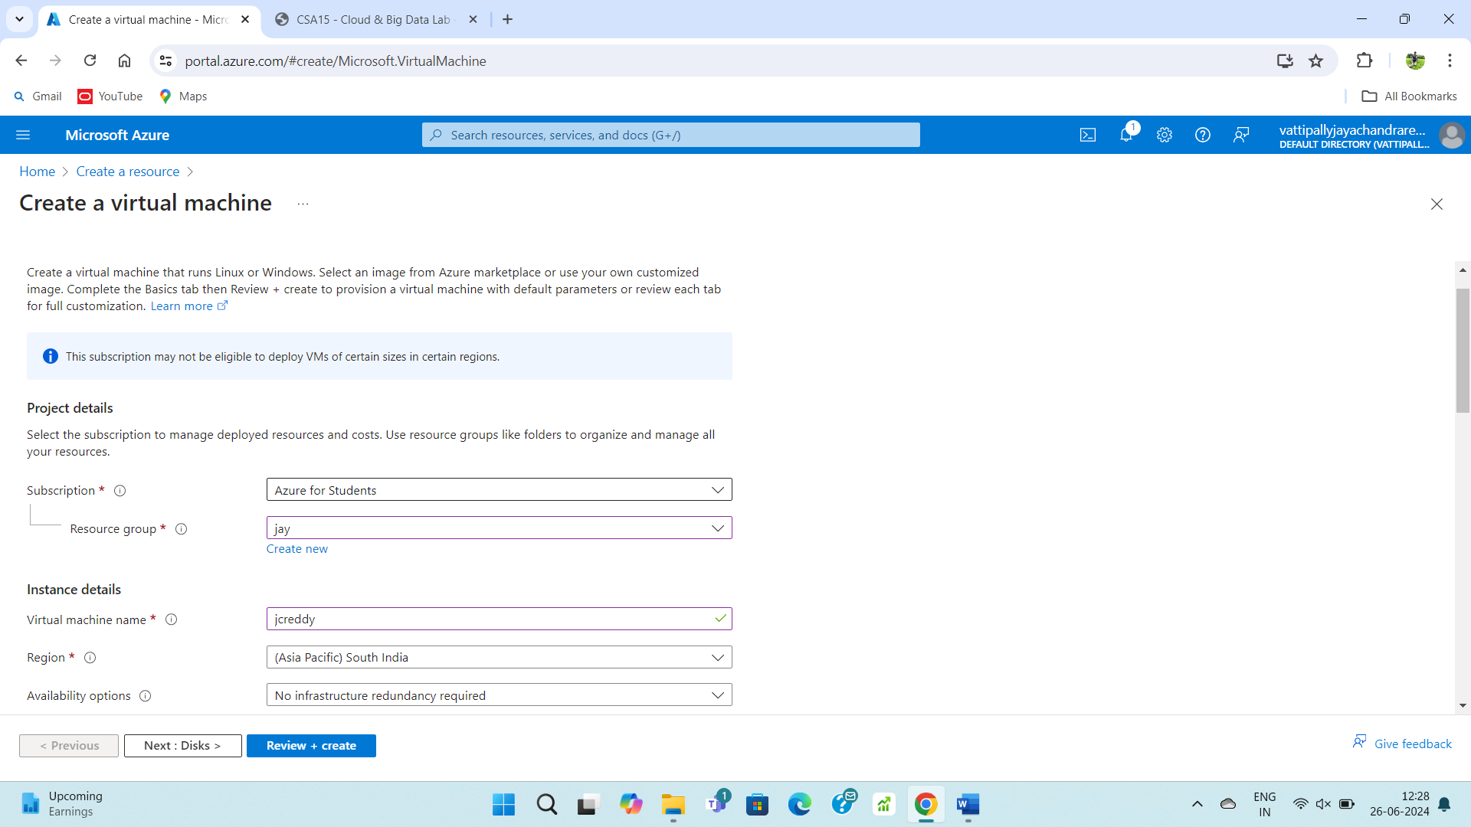

**STEP – 3:**

Fill upon the disk form.

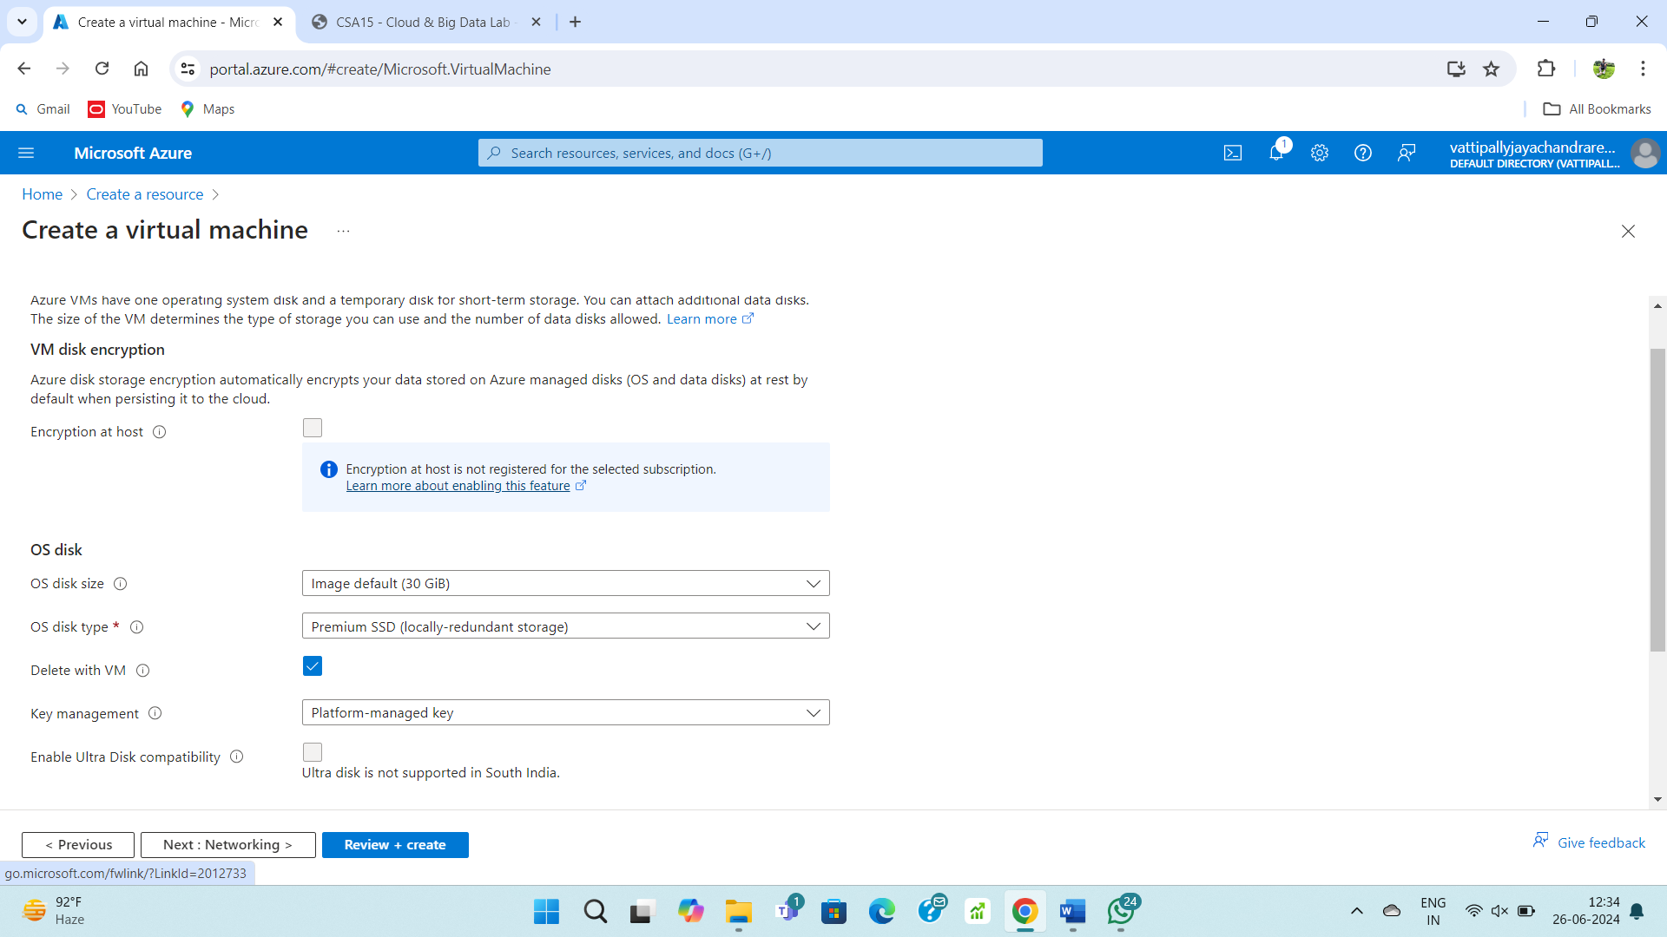

**STEP – 4:**

Fill upon the networking form.

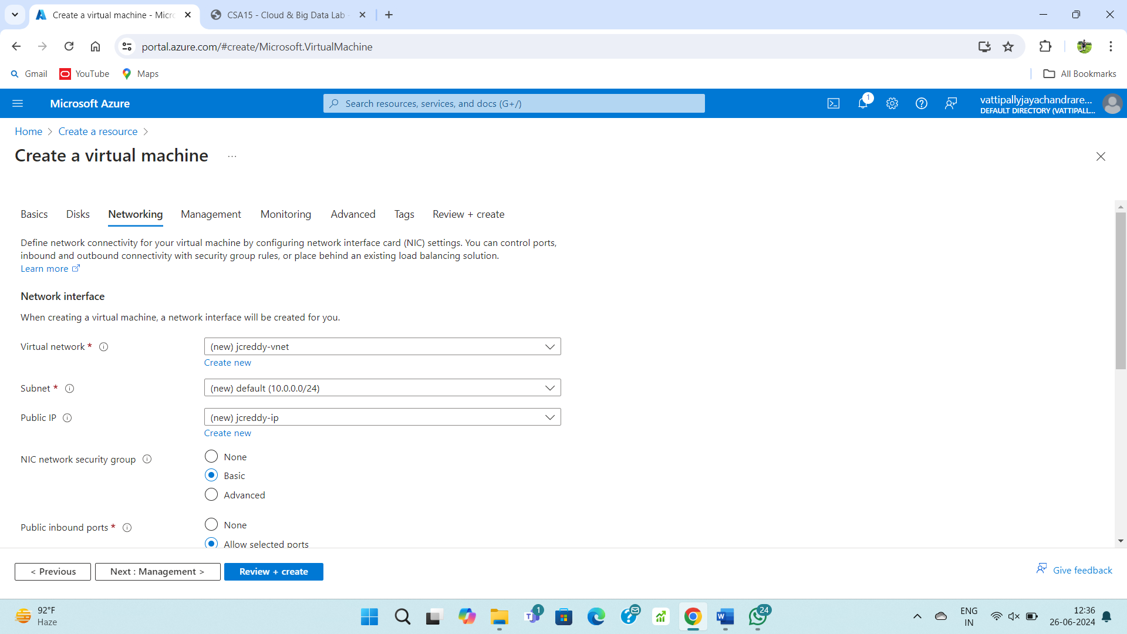

**STEP – 5:**

Fill upon the management form.

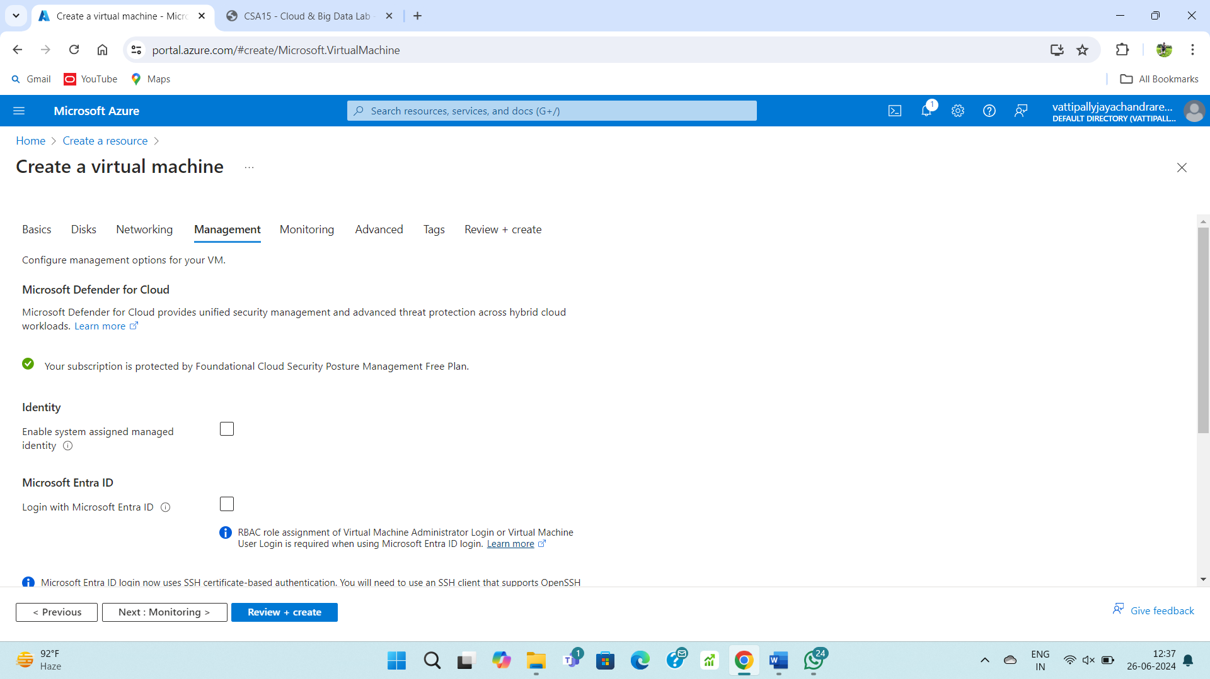

**STEP – 6:**

Fill upon the monitoring form.

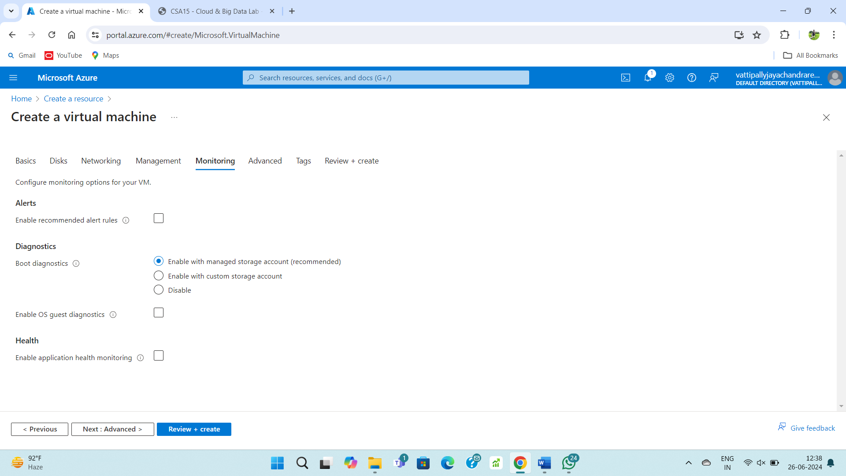

**STEP – 7:**

Fill upon the advanced form.

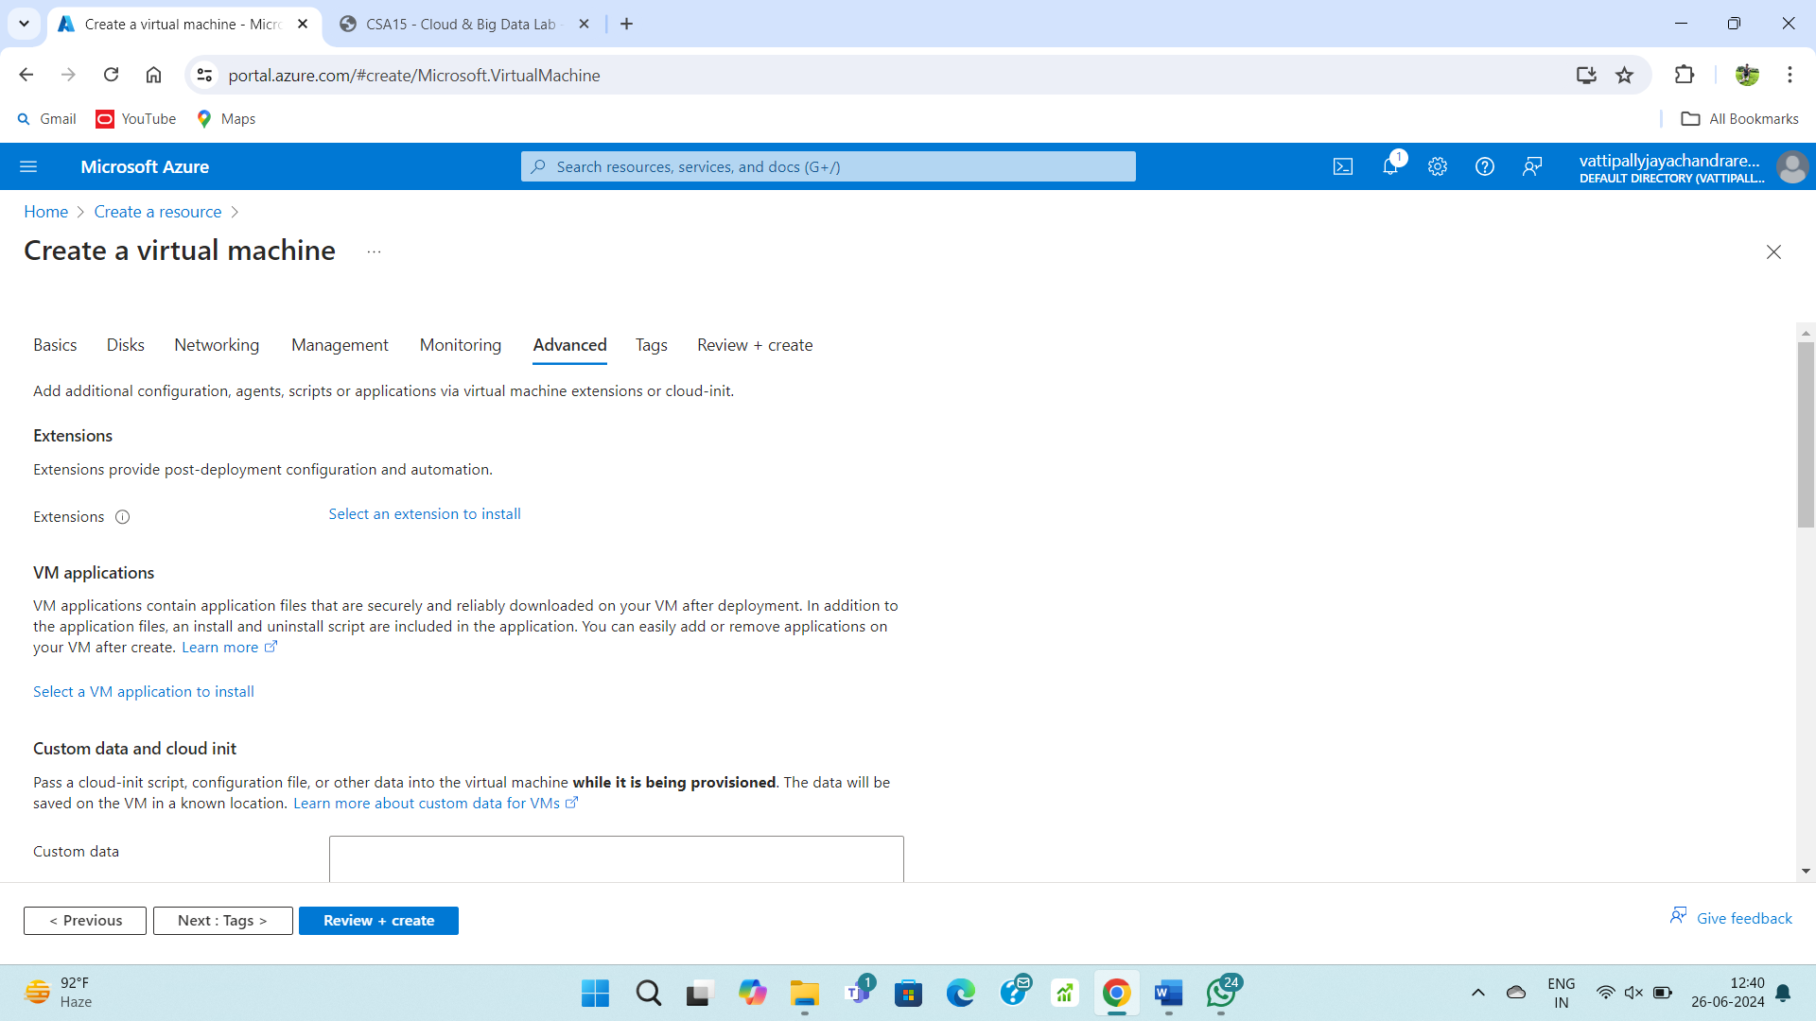

**STEP – 8:**

Fill upon the tags form.

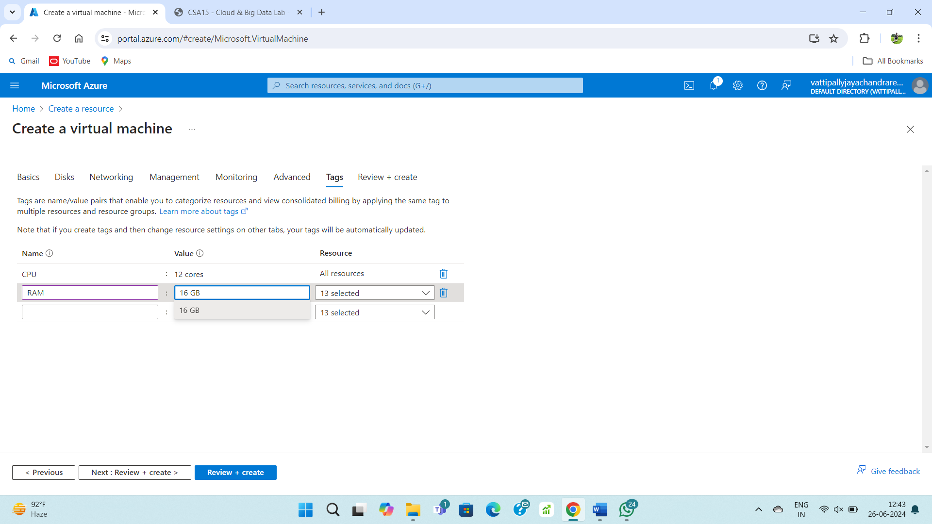

**STEP – 9:**

Review and create the virtual machine.

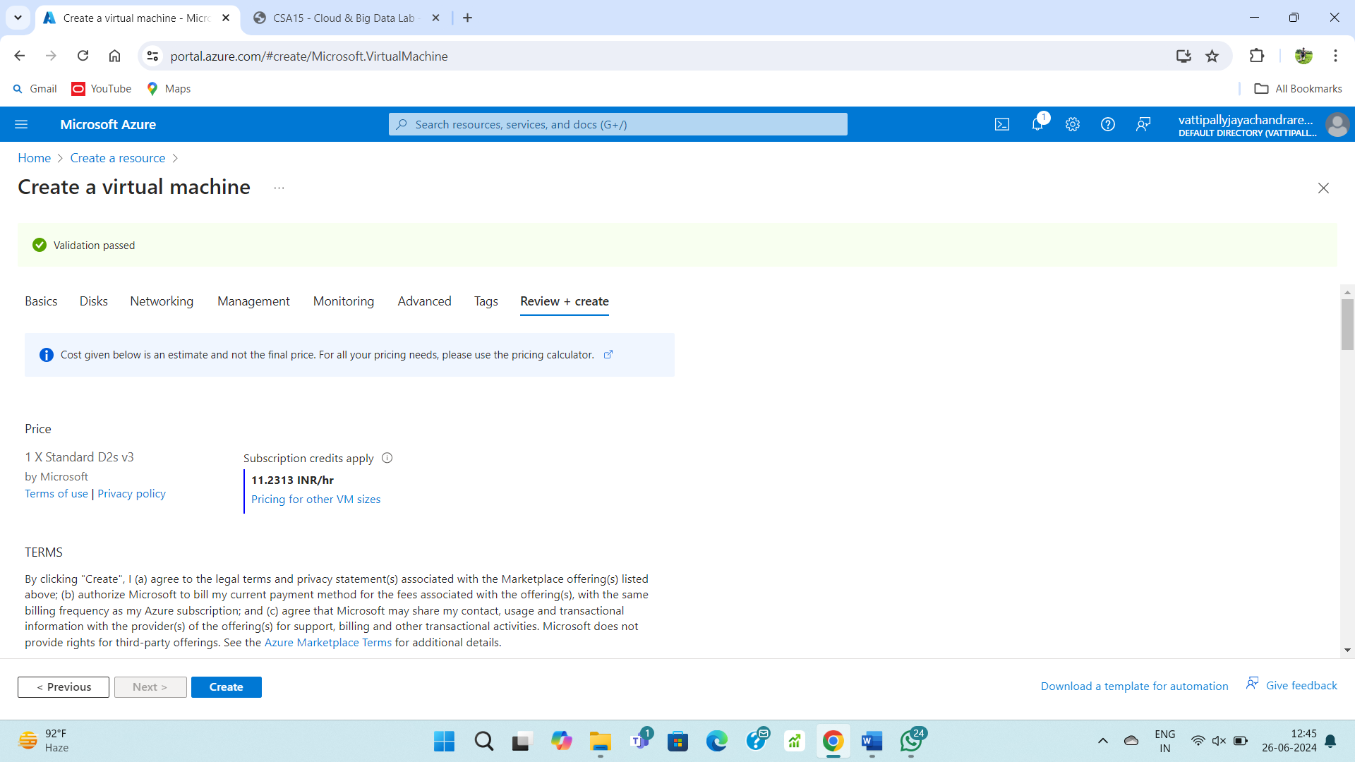

**STEP – 10:**

Once deployment is complete then your VM is ready to use.

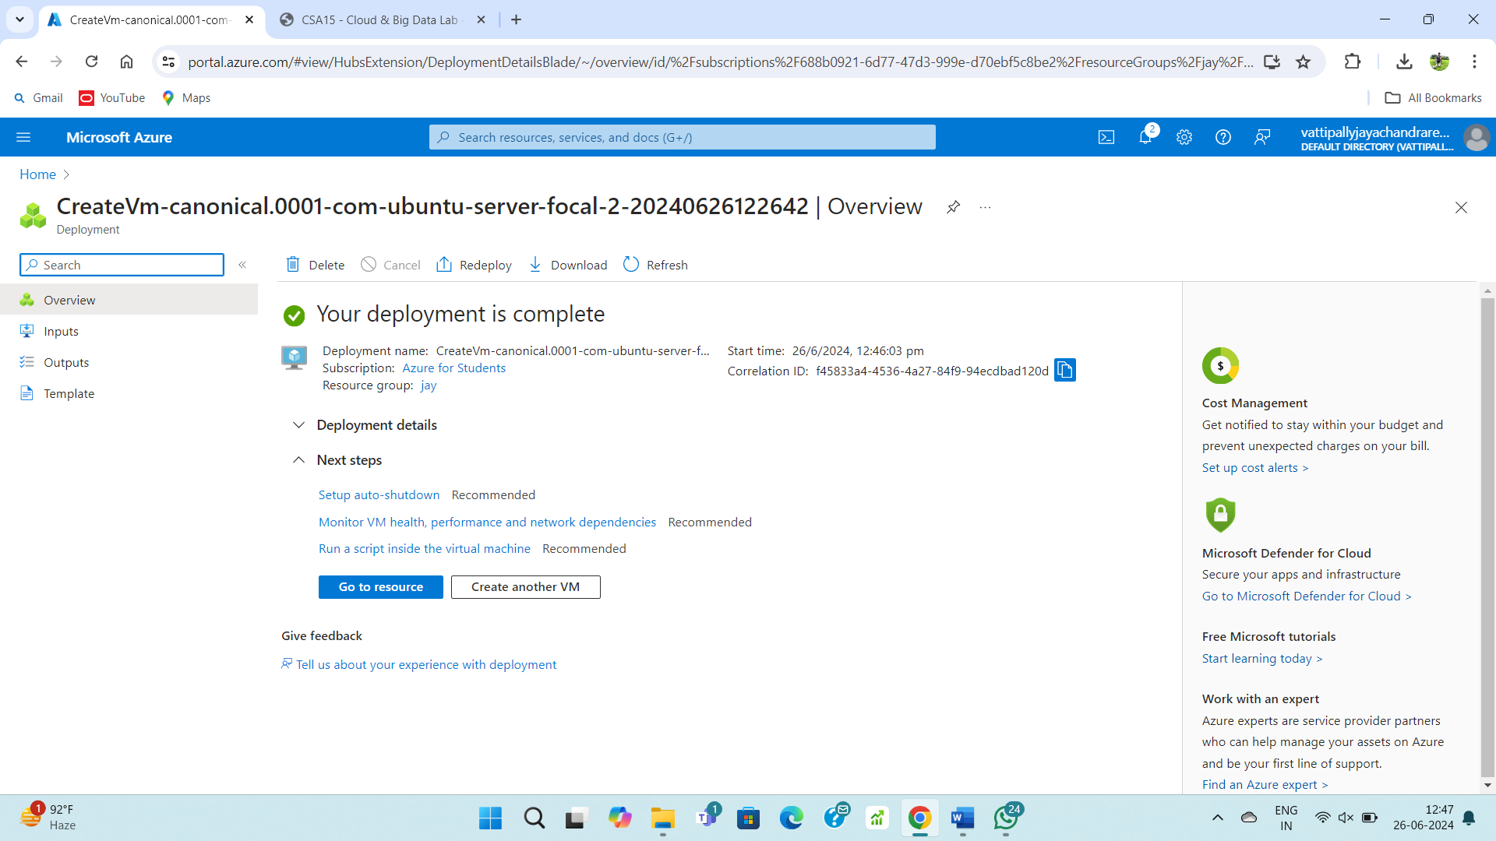

**STEP – 11:**

After going into the created resource u can have all specs of VM and u can use it.

